Assignment 8

1. When to use (Rapid Application Development) RAD model. When not to use (Rapid Application Development) RAD model.

Ans) When to use RAD Model

- RAD Model is used for the smalls project when product needs to be produced in a short span of time.
- And also this model helps to reduce risks.
- With fewer people productivity is increased in short duration. Here customer is involved.
- All the requirements are gathered before starting development of the project. RAD Model is similar to incremental model and waterfall model. Development should be done in specified time frame. Development starts as soon as requirement is gathered. Initial working prototype is given to the client to get the feedback. Once client gives the feedback, based on the client’s feedback other changes are made.
- Each prototype is delivered to the client with some working functionality and changes made based on the client’s feedback.
- Development moves faster in RAD Model with minimum errors.

When not to use RAD model

- RAD model cannot be used if the total budget for the project is low. Since the cost for modelling, automatic code generation etc is higher.
- RAD model can be used only if there is a strong technical team.
- RAD cannot be used for large or highly complex project

2. Define an ER diagram of a software Organization with all the relationship model that was discussed in the classroom

Employee
E_name
E_address
E_ID
E_designation
E_sal
Belongs_to
Dept
D_ID
D_name
Works_on
Projects
P_ID
P_name
P_description
IP_name
Request
Clients
C_ID
I_ID
C_address
C_name
Requires
Items
I_description
1
n
n
1
n
n
1
n
First_name
Third_name
Sec_name
DOB
Phone
Age
Phone
Phone
Phone
Phone
Phone
Location
Street
House_name

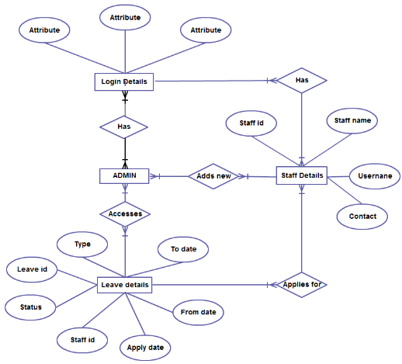
3. Describe the Entity Relationships for the following diagram

Ans)

Entities
Login Details, Leave details, Admin , Staff details are the entities.
Relationships
Has, Applies for, Accesses shows the relationships between entities.

Staff
- Staff id is the primary key.
- Many staff has differnt login that is many to many relation.
- Many staff applies for many leaves that is many to many relation.
- Staff details has staff name,user name,contacts,staff id.

Admin

- Admins can add new staffs. Many to many relation.
- Leave deatils can be accessed by Admin and is many to many relation.
- Admin has relationship with Login deatils.

Leave details

- Leave deatils has the following attributes type,leave id,status,staff id,apply date,from date,to date.
- Leave id primary key here
- The foreign key staff id used in this entity.

